Gastoskwela: A Student Allowance and Expense Tracking Application

Submitted By:
BSIS-2C
Alfaro, Maxwell James C.
Eugenio, John Erick R.
Perez, Raeven M.
Rodiel, Rainier James P.
Talucud, Catherine
Submitted To:
Mr. Kyle Joseph G. Fabian
Bulacan Polytechnic College
Instructor

Date: October 24, 2026

1. PROJECT OVERVIEW

1.1 Project Description
Gastoskwela: A Student Allowance and Expense Tracking Application is a mobile application developed to help students manage their daily allowances and expenses. The application provides a simple and organized way to record income from allowances, track spending, monitor remaining balances, and review financial reports.
The application was developed using Kotlin for application logic, XML for user interface design, and Room Database with SQLite for local data storage. Gastoskwela is designed to work offline, allowing students to manage their financial records without requiring an internet connection.

1.2 Problem Statement
Many students experience difficulties managing their allowances because they do not consistently monitor their daily expenses. Small purchases, transportation costs, meals, and other personal expenses can accumulate over time, making it difficult to determine how much money has been spent and how much remains.
Without an organized expense-tracking system, students may struggle to understand their spending habits and manage their available allowance effectively. Therefore, a simple and accessible mobile application is needed to help students record their expenses and monitor their financial activities.

1.3 Target Users
The primary target users of Gastoskwela are college and senior high school students who receive daily, weekly, or monthly allowances.
The application is particularly useful for students who want to monitor their spending, organize expense records, and develop better money management habits. Its simple interface also makes it suitable for students who have limited experience using financial management applications.

1.4 Proposed Solution
Gastoskwela aims to address these problems by providing an offline mobile application that allows students to manage their allowances and expenses in one place.
The application includes four main sections: Home, Expenses, Allowance, and Reports. The Home section displays a summary of the student's financial information. The Expenses section allows users to add, view, edit, and delete expense records. The Allowance section manages allowance entries and history, while the Reports section provides visual summaries of spending activities.
By automatically calculating expenses and remaining balances, Gastoskwela helps students understand where their money goes and make more informed financial decisions.

2. OBJECTIVES, SCOPE AND FEATURES

2.1 General Objective
The general objective of Gastoskwela: A Student Allowance and Expense Tracking Application is to develop a user-friendly Android mobile application that helps students manage their allowances, monitor daily expenses, and track their financial activities. The application aims to promote better financial awareness by providing an organized and accessible way to record and review personal spending.

2.2 Specific Objectives
The specific objectives of the application are:
- To develop a mobile application that allows students to record and manage their daily, weekly, or monthly allowances.
- To provide an expense-tracking system where students can add, view, edit, and delete their expense records.
- To automatically calculate total allowances, expenses, and remaining balances.
- To organize expenses into categories for easier tracking and monitoring.
- To generate financial reports and visual summaries that help students understand their spending habits.
- To develop a simple and user-friendly interface that allows students to navigate the application easily.
- To implement a local database that stores financial records and allows the application to function without an internet connection.
- To test the application's functionality, accuracy, and reliability on Android devices.

2.3 Scope and Limitations

Scope
Gastoskwela is designed primarily for college and senior high school students who want to manage their personal allowances and expenses.
The application allows users to record allowances, track expenses, view transaction histories, and monitor their remaining balances. It provides expense categories to help students organize their spending and includes financial reports that display summaries of their financial activities.
The application consists of four main sections: Home, Expenses, Allowance, and Reports. It uses Kotlin for application logic, XML for user interface design, and Room Database with SQLite for local data storage.
Gastoskwela operates offline, allowing students to access and manage their financial records without requiring an internet connection.

Limitations
Despite its functionality, Gastoskwela has the following limitations:
- Android Only: The application is developed for Android devices and is not available for iOS.
- Offline Storage: Financial records are stored locally on the device and are not automatically synchronized across multiple devices.
- No Cloud Backup: The application does not currently provide automatic cloud backup or online data recovery.
- Manual Data Entry: Users must manually enter their allowances and expenses because the application does not automatically connect to banks or digital wallets.
- No Financial Transactions: The application is designed for tracking financial activities and does not support actual money transfers or payments.
- No User Account Synchronization: The application does not provide cloud-based account synchronization between devices.

2.4 Major Features
Gastoskwela includes the following major features:
1. Home Dashboard
The Home Dashboard provides an overview of the student's financial information, including total allowance, recorded expenses, and remaining balance. It allows users to quickly monitor their current financial status.
2. Expense Management
The Expenses section allows users to add, view, edit, and delete expense records. Users can enter the amount, category, description, and date of each expense. The section also provides search and filtering options for easier record management.
3. Allowance Management
The Allowance section allows students to record and manage their allowances. It supports allowance tracking and displays allowance history to help users monitor the money they receive.
4. Financial Reports
The Reports section provides summaries and visual representations of the student's spending activities. These reports help users identify spending patterns and understand how their allowance is being used.
5. Automatic Balance Calculation
The application automatically calculates the remaining balance based on recorded allowances and expenses. This reduces the need for manual calculations and helps students monitor their available money.
6. Expense Categorization
Users can organize their expenses into different categories, such as Food, Transportation, Groceries, Subscriptions, and Others. This makes it easier to identify where their money is being spent.
7. Offline Data Storage
Gastoskwela uses Room Database with SQLite to store financial records locally. Users can access and manage their information without an internet connection.
8. User-Friendly Interface
The application features a consistent layout, readable text, organized financial cards, and simple navigation. Its interface is designed to make allowance and expense tracking convenient for students.
3. System Design
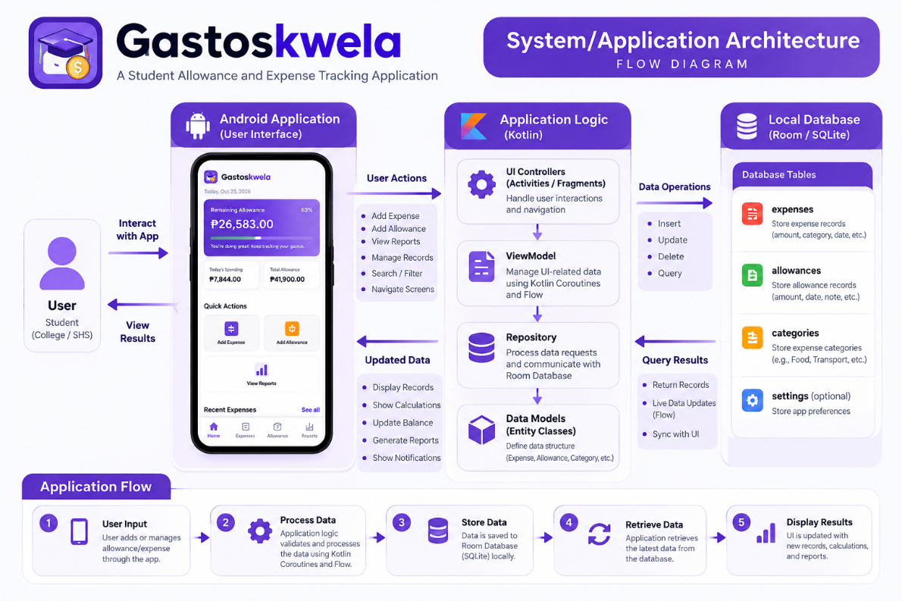

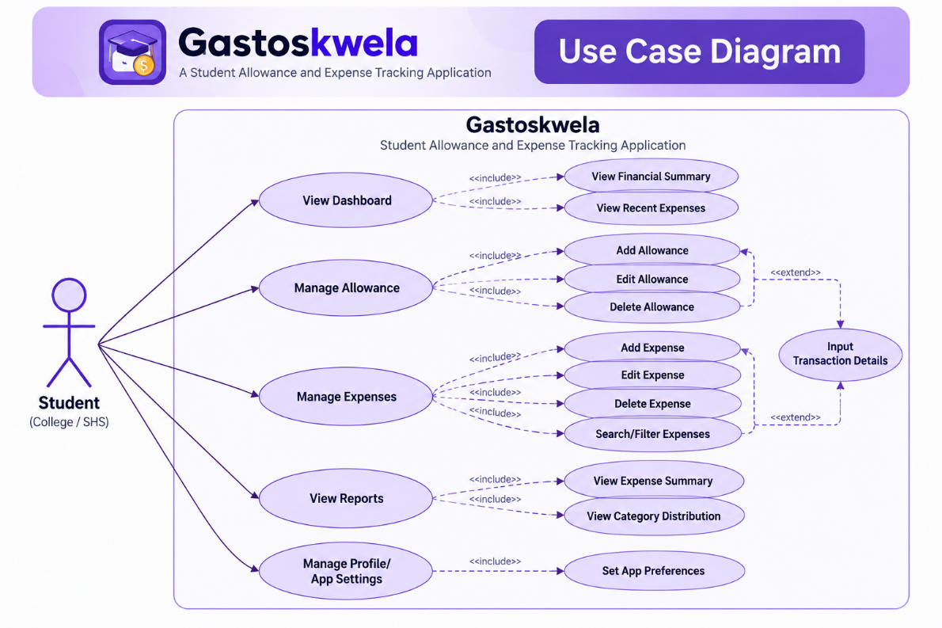

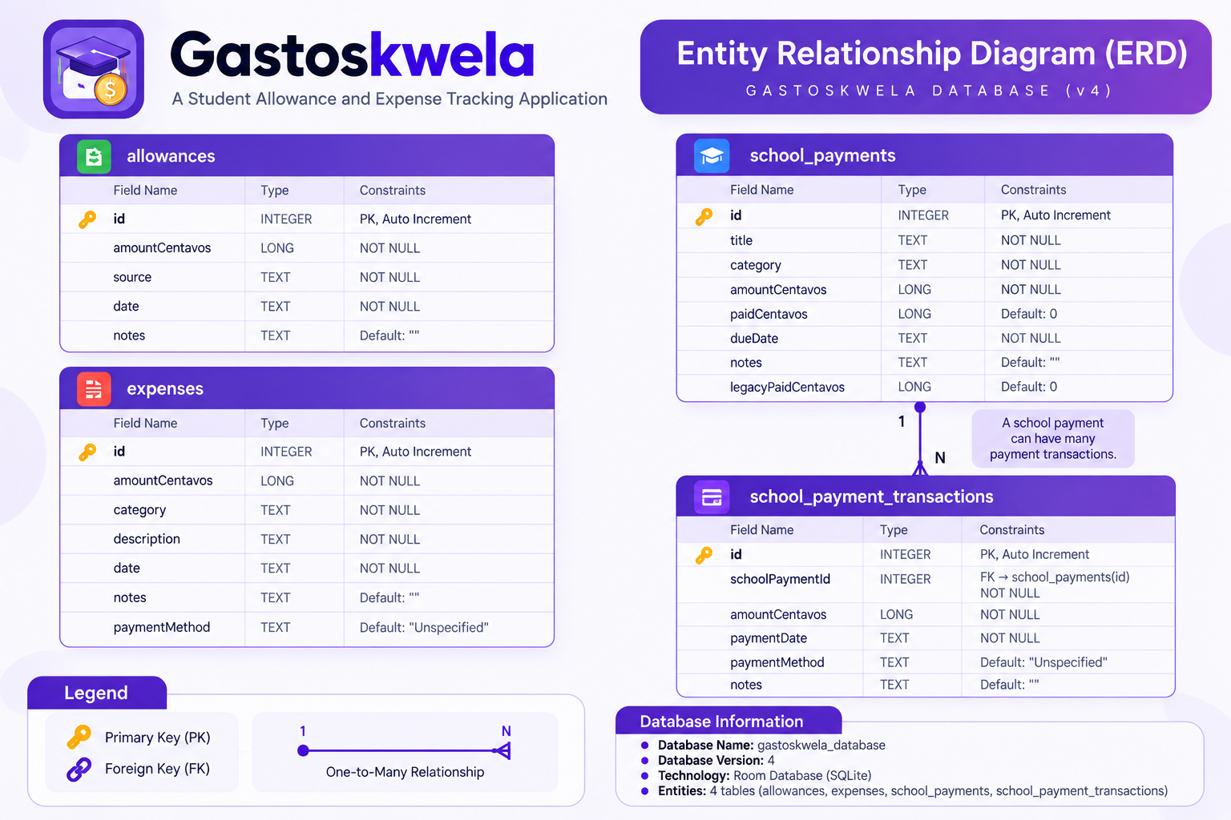

4. UI/UX AND IMPLEMENTATION

4.1 UI/UX Design
Gastoskwela was designed with a simple, modern, and user-friendly interface to help students manage their allowances and expenses efficiently. The application focuses on usability, consistency, and accessibility to ensure that users can easily understand and navigate its features.
The application uses a purple color theme to establish a consistent visual identity. It also uses readable typography, organized financial cards, clear icons, and appropriately spaced buttons to improve the overall user experience.
The user interface follows a structured layout that allows students to access important financial information without unnecessary steps. A bottom navigation bar provides access to the four main sections: Home, Expenses, Allowance, and Reports.
The application also includes onboarding screens that introduce its purpose and features to first-time users. These screens help users understand the application before proceeding to allowance setup and expense tracking.
The UI/UX design follows these principles:
- Consistency: Uniform colors, typography, icons, and layouts are used throughout the application.
- Usability: Simple navigation and clearly labeled buttons make the application easy to operate.
- Visual Hierarchy: Important financial information, such as remaining balance and total expenses, is displayed prominently.
- Accessibility: Readable text, appropriate color contrast, and recognizable icons improve usability.
- Responsive Design: Layouts are designed to accommodate different Android screen sizes.

4.2 Development Tools
The following development tools were used in creating Gastoskwela:
1. Android Studio
Android Studio served as the primary Integrated Development Environment (IDE) for developing, building, debugging, and testing the application.
2. Git
Git was used for version control, allowing the developers to track changes, manage branches, and maintain the project's development history.
3. GitHub
GitHub was used as the online repository for storing the source code, managing project versions, and supporting collaboration among group members.
4. Gradle
Gradle was used as the project's build automation system. It manages dependencies, build configurations, and the generation of Android application packages (APK).
5. Android Emulator and Physical Android Devices
Android testing tools and compatible physical devices were used to check the application's interface and functionality during development.

4.3 Technologies Used
The application was developed using the following technologies:
1. Kotlin
Kotlin is the primary programming language used to implement the application's logic and functionality. It handles user interactions, input validation, calculations, and database operations.
2. XML (Extensible Markup Language)
XML was used to design the application's user interface, including buttons, text fields, financial cards, navigation components, and screen layouts.
3. Room Database
Room is an Android database library used to manage local data storage. It provides a structured way to insert, retrieve, update, and delete financial records.
4. SQLite
SQLite is the underlying database engine used to store allowance and expense records locally on the device, allowing Gastoskwela to function offline.
5. Data Access Object (DAO)
DAO interfaces define the database operations used by the application. These operations include creating, reading, updating, and deleting records.
6. Entity Classes
Entity classes define the structure of database tables, including fields such as record ID, amount, category, description, and date.
7. Kotlin Coroutines and Flow
Coroutines are used to perform asynchronous operations without blocking the main user interface. Flow allows the application to observe changes in stored data and update displayed information.
8. Android Fragments
Fragments are used to organize the application into separate sections while allowing users to navigate between screens within the main Activity.
9. Material Components
Material Components were used to support consistent and user-friendly interface elements throughout the application.

4.4 Major Application Screens
Gastoskwela consists of several screens that support its financial tracking features.
1. Splash Screen
The Splash Screen displays the Gastoskwela branding when the application is launched.
2. Onboarding Screens
The onboarding screens introduce the application's purpose and explain its main benefits, including allowance management, expense tracking, and financial awareness.
3. Allowance Setup Screen
The Allowance Setup Screen allows first-time users to configure their initial allowance information before using the application's main features.
4. Home Screen
The Home Screen serves as the application's dashboard. It displays an overview of the student's allowance, total expenses, and remaining balance.
5. Expenses Screen
The Expenses Screen allows users to record, view, edit, delete, search, and filter their expenses. Each record contains relevant information, such as amount, category, description, and date.
6. Allowance Screen
The Allowance Screen allows users to manage their allowances and view previous allowance records.
7. Reports Screen
The Reports Screen displays financial summaries and visual reports that help students understand their spending activities and expense distribution.

4.5 Feature Implementation
The major features of Gastoskwela were implemented using Kotlin, XML, and Room Database.
1. Allowance Management Implementation
The allowance management feature allows users to record and manage their allowance entries. Kotlin handles input validation and processing, while Room Database stores the records locally. The application uses the stored allowance information to calculate the user's available balance.
2. Expense Tracking Implementation
The expense tracking feature allows users to create, view, update, and delete expense records. Users enter the expense amount, category, description, and date through the interface. Kotlin validates the information, and DAO methods perform the required database operations.
3. Automatic Balance Calculation
The application calculates the remaining balance based on recorded allowances and expenses. Money values are stored in centavos using the Kotlin Long data type to reduce floating-point rounding errors during financial calculations.
4. Financial Reports Implementation
The reporting feature retrieves stored financial records and processes them to generate spending summaries and visual reports. This allows users to monitor their expenses and identify spending patterns.
5. Search and Filtering Implementation
The Expenses section provides search and filtering functions to help users locate specific expense records. These features improve record organization and make financial information easier to access.
6. Local Database Implementation
Room Database and SQLite were integrated to provide persistent offline data storage. Entity classes define the database tables, while DAO interfaces handle database operations. This allows the application to retain financial records between sessions.
7. Navigation Implementation
The application's navigation system uses Android Activities and Fragments. The MainActivity manages the primary application interface, while individual Fragments display the Home, Expenses, Allowance, and Reports sections.
8. User Input Validation
Input validation is implemented to prevent invalid financial records. For example, the application checks monetary amounts before saving them to the database. This helps maintain data accuracy and improves application reliability.

5. TESTING AND EVALUATION

5.1 Test Cases
Functional testing was designed to evaluate the major features of Gastoskwela and determine whether the application performs its intended operations correctly. The test cases focus on application navigation, allowance management, expense tracking, automatic calculations, financial reports, and offline data storage.
The following table presents the ten functional test cases used for evaluating the application.
Test ID | Test Case | Expected Result
TC-01 | Launch the application | The application opens successfully without crashing.
TC-02 | Navigate between main screens | The Home, Expenses, Allowance, and Reports screens open correctly.
TC-03 | Add a new allowance | The allowance is saved and displayed correctly.
TC-04 | Add a new expense | The expense is recorded and displayed in the expense list.
TC-05 | Edit an existing expense | The updated expense information is saved correctly.
TC-06 | Delete an expense | The selected expense is removed from the records.
TC-07 | Calculate remaining balance | The remaining balance is calculated accurately based on recorded allowances and expenses.
TC-08 | Search and filter expenses | The application displays records matching the selected search or filter criteria.
TC-09 | View financial reports | The application displays financial summaries and spending information correctly.
TC-10 | Test offline data storage | Financial records remain accessible without an internet connection and after restarting the application.

5.2 Testing Results
The functional testing of Gastoskwela focuses on verifying that its major features operate according to their intended purpose.
The final project presentation reports that all ten functional test cases passed successfully. These results indicate that the tested features performed their expected functions during evaluation.
Test ID | Reported Result
TC-01 | PASSED
TC-02 | PASSED
TC-03 | PASSED
TC-04 | PASSED
TC-05 | PASSED
TC-06 | PASSED
TC-07 | PASSED
TC-08 | PASSED
TC-09 | PASSED
TC-10 | PASSED
Reported Testing Summary
- Total Test Cases: 10
- Passed: 10
- Failed: 0
- Reported Pass Rate: 100%
These results should be supported by actual test execution records, including screenshots or other evidence, to confirm that the application meets the expected functional requirements.
The testing process also emphasizes the importance of input validation, accurate financial calculations, database reliability, and application stability.

5.3 User Evaluation
Gastoskwela was designed with usability and accessibility in mind, particularly for college and senior high school students who need a convenient way to manage their allowances and expenses.
The application provides clearly labeled navigation controls, organized financial information, readable text, and straightforward data-entry forms. These design decisions aim to make the application easy to understand and use.
A formal user evaluation may be conducted by allowing students to use the application and provide feedback regarding its functionality, interface design, navigation, and overall usefulness.
If conducted, the evaluation may assess the following criteria:
- Ease of Use: How easily users can understand and operate the application.
- Interface Design: The clarity, consistency, and appearance of the user interface.
- Navigation: How easily users can access the application's main features.
- Functionality: Whether the features work according to user expectations.
- Usefulness: How effectively the application helps students monitor allowances and expenses.
No formal user survey results are included in this section because verified respondent data and evaluation scores have not been provided.

5.4 Testing Conclusion
The reported functional testing results indicate that Gastoskwela successfully performed the ten selected test cases. The application is designed to provide reliable allowance tracking, expense management, automatic balance calculations, and financial reporting.
Further testing on different Android devices and additional user evaluation may help identify possible improvements and ensure consistent performance across various usage conditions.

6. CONCLUSION AND RECOMMENDATIONS

6.1 Project Accomplishments
The development of Gastoskwela: A Student Allowance and Expense Tracking Application successfully produced an Android mobile application designed to help students manage their allowances and daily expenses.
The application provides essential features such as allowance management, expense tracking, automatic balance calculations, and financial reports. These features allow students to organize their financial records, monitor their spending activities, and understand how their allowances are being used.
Gastoskwela was developed using Kotlin for application logic, XML for user interface design, and Room Database with SQLite for local data storage. The application also implements Create, Read, Update, and Delete (CRUD) operations to manage financial records efficiently.
The project achieved the following accomplishments:
- Developed a functional Android application with a user-friendly interface.
- Implemented allowance and expense management features.
- Integrated a local database for offline financial record storage.
- Implemented automatic calculations for allowances, expenses, and remaining balances.
- Developed financial reports to help users understand their spending habits.
- Created organized navigation between the application's main sections.
- Used Git and GitHub for source code management and team collaboration.
Overall, Gastoskwela demonstrates the practical application of mobile development concepts in addressing common financial management challenges experienced by students.

6.2 Problems Encountered
During the development of Gastoskwela, the team encountered several technical challenges that required troubleshooting, testing, and improvements.
1. Database Integration
Implementing Room Database required proper configuration of entities, Data Access Objects (DAOs), and database operations. The team worked on ensuring that financial records could be saved, retrieved, updated, and deleted correctly.
2. Financial Calculations
Maintaining accurate allowance and expense calculations was an important challenge. The application uses integer-based centavo values to reduce rounding errors and improve the accuracy of financial records.
3. User Interface Design
Creating a consistent and user-friendly interface required adjustments to screen layouts, navigation, spacing, and visual elements. The team focused on making the application understandable and convenient for students.
4. Application Navigation and Data Updates
Connecting different application sections and ensuring that displayed financial information remained updated required proper implementation of Android Fragments, Kotlin Coroutines, and Flow.
5. Debugging and Application Builds
The development process involved resolving coding errors, dependency configuration issues, and build-related problems. Testing and debugging were necessary to improve application stability and prepare the APK for demonstration.
6. Version Control and Team Collaboration
Managing source code changes through Git and GitHub required coordination among team members. Branch management and integration of updates were important in maintaining an organized project repository.

6.3 Recommendations and Future Improvements
Although Gastoskwela provides the essential features needed for student allowance and expense tracking, several improvements may be considered in future versions.
1. Cloud Backup and Synchronization
Future versions may include cloud storage to allow users to back up their financial records and access them across multiple devices.
2. Expense Notifications and Reminders
Adding notifications may help remind students to record expenses and monitor their remaining allowances.
3. Budget Planning Features
A budget planning feature may allow students to set spending limits for specific categories and monitor their progress.
4. Data Export
Future development may include exporting financial reports into PDF or spreadsheet formats for easier record keeping.
5. Advanced Financial Analytics
Additional charts, spending comparisons, and financial insights may help students better understand their financial habits.
6. Cross-Platform Compatibility
Developing an iOS-compatible version may make the application accessible to more students.
In conclusion, Gastoskwela provides a practical and accessible solution for student allowance and expense management. The project demonstrates how mobile application development can be used to address everyday financial challenges and encourage responsible spending habits among students.

APPENDICES
Github Repository: https://github.com/clarxxinn/Gastoskwela

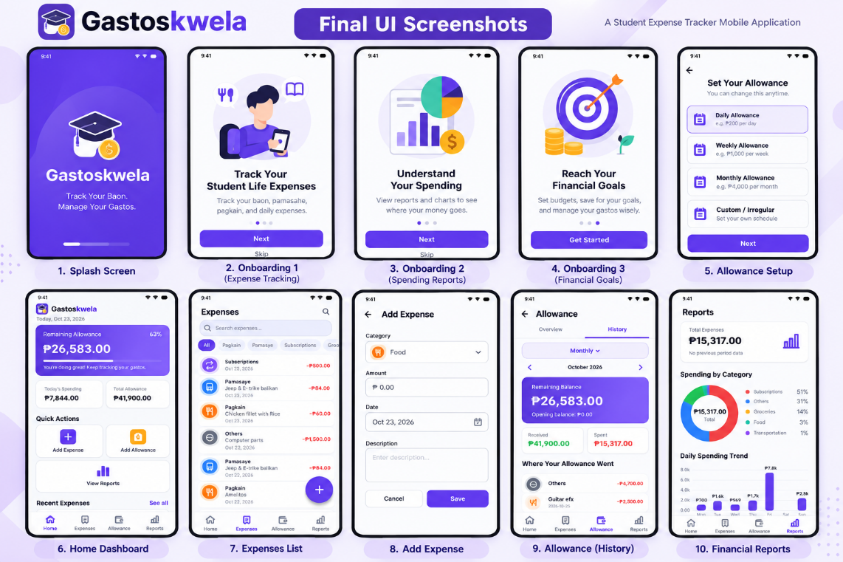

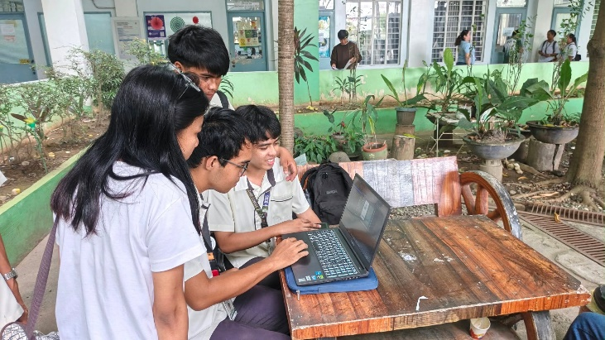
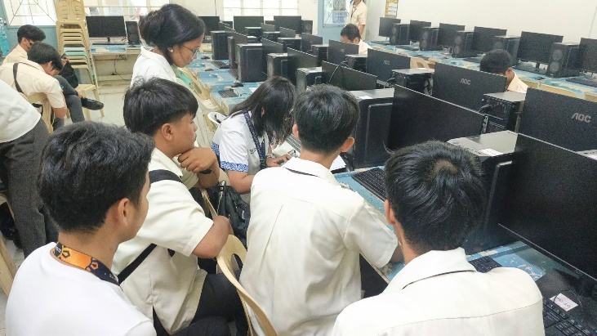

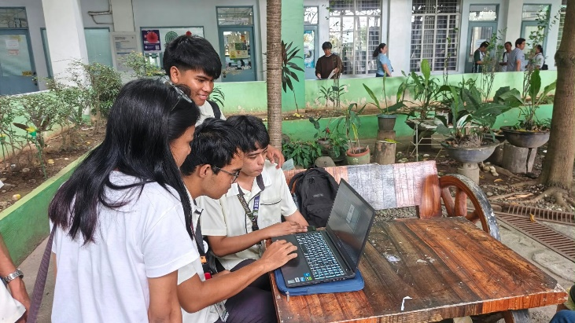
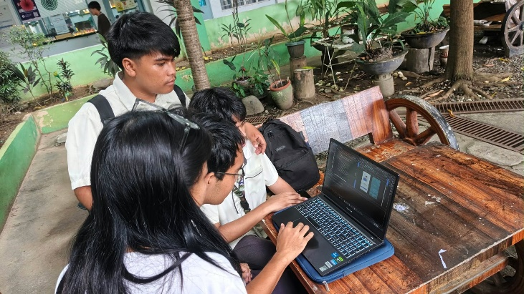

FINAL SCORE SUMMARY (Include this in your documentation)
Criteria | Maximum | Score
A. Functionality & Features | 25 | ____
B. UI/UX Design & Usability | 20 | ____
C. Technical Implementation | 20 | ____
D. Testing & Reliability | 10 | ____
E. GitHub & Source Code Management | 10 | ____
F. Documentation | 5 | ____
G. Presentation & Demonstration | 10 | ____
TOTAL | 100 | ____ / 100
Final Rating
Raw Score: ______ / 100
Equivalent Grade: __________________
Evaluator's Overall Comments:

XIX. PROJECT EVALUATION DECISION
☐ APPROVED – Project meets the required standards.
☐ APPROVED WITH MINOR REVISIONS – Project is acceptable but requires minor corrections.
☐ FOR REVISION – Significant improvements are required before final acceptance.
☐ NOT ACCEPTED – Project does not meet the minimum project requirements.
Required Revisions:

XX. EVALUATOR SIGNATURE
Evaluated by:
Name: ______________________________________
Signature: ___________________________________
Date: ________________________________________

